**Titanic Dataset**

**Rules with support=0.01 and confidence= 0.9**

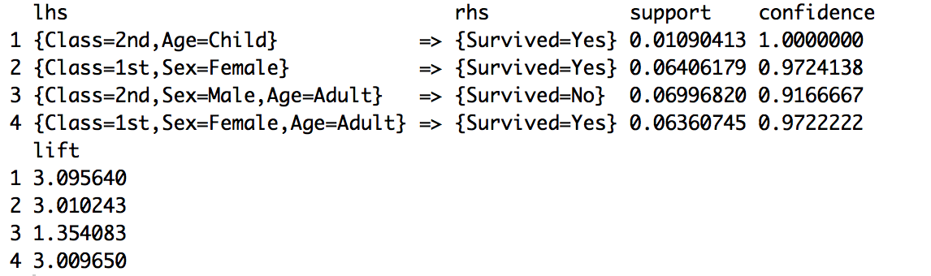

**Rules that aren’t redundant with support=0.01 and confidence=0.9:**



**Rules that aren’t redundant, sorted by lift, with support=0.01 and confidence=0.9:**

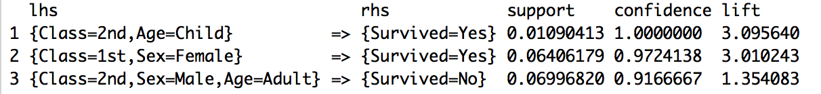

**Retail Dataset**

**Rules with support=0.01 and confidence= 0.9: (first six since 11387 were found)**

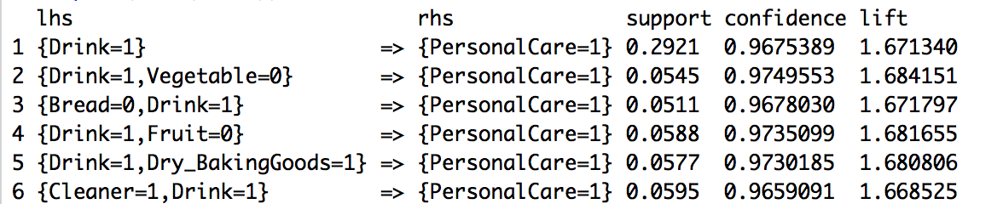

**Rules that aren’t redundant with support=0.01 and confidence=0.9: (first six since 210 were found)**

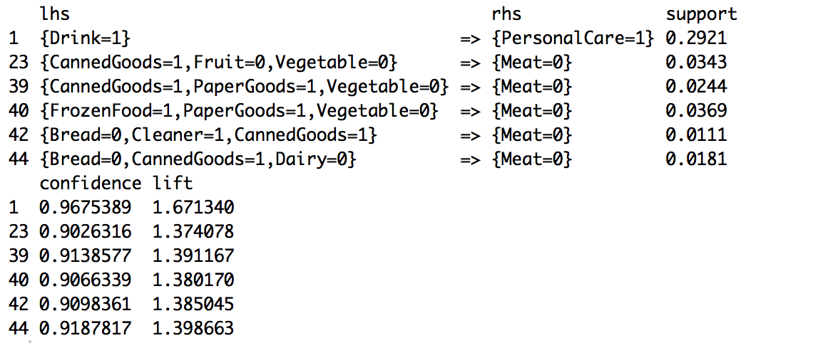

**Rules sorted by lift:**

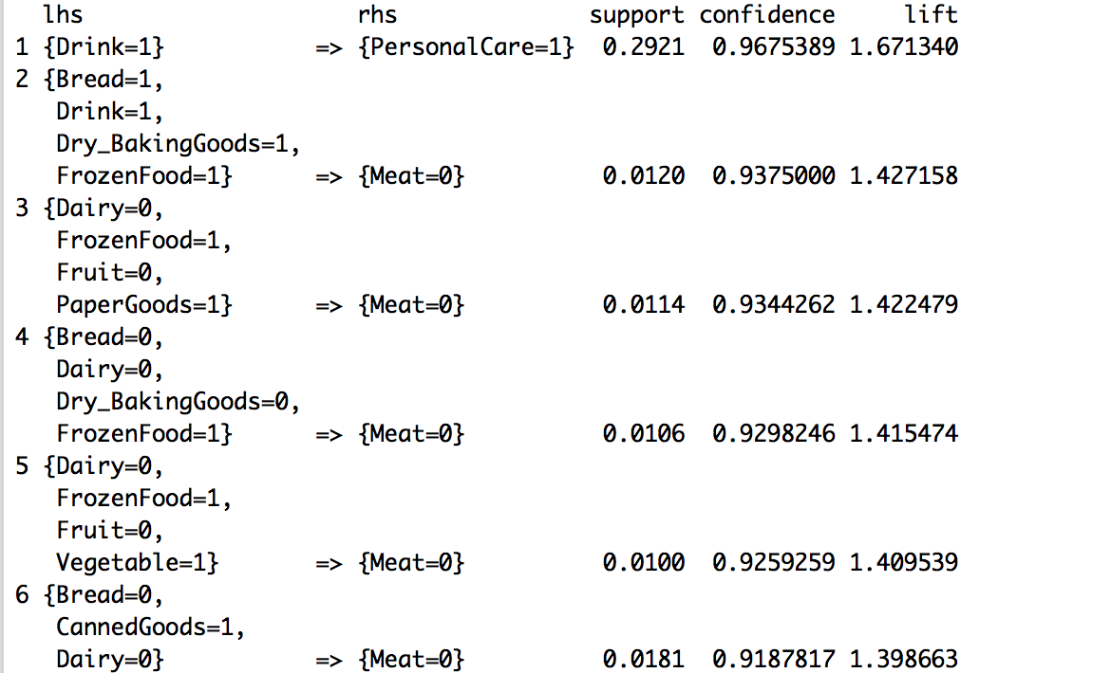

**Game of Thrones Dataset**

**Rules with support=0.01 and confidence= 0.9: (first 6 again)**

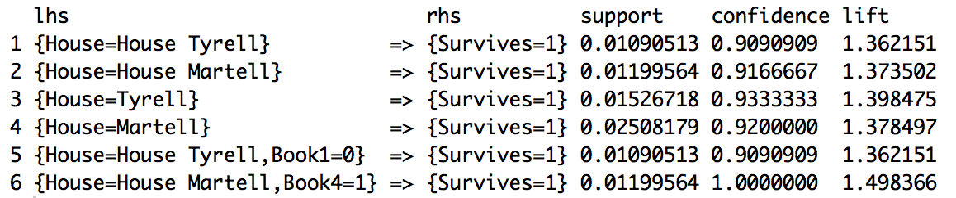

**Rules that aren’t redundant:**

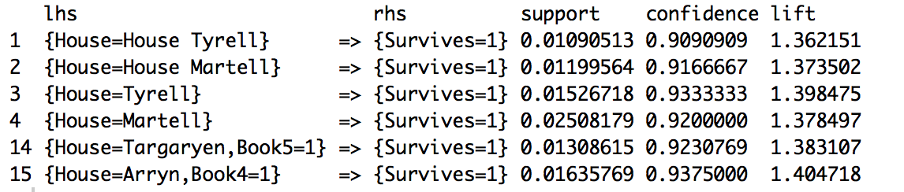

**Rules sorted by lift:**

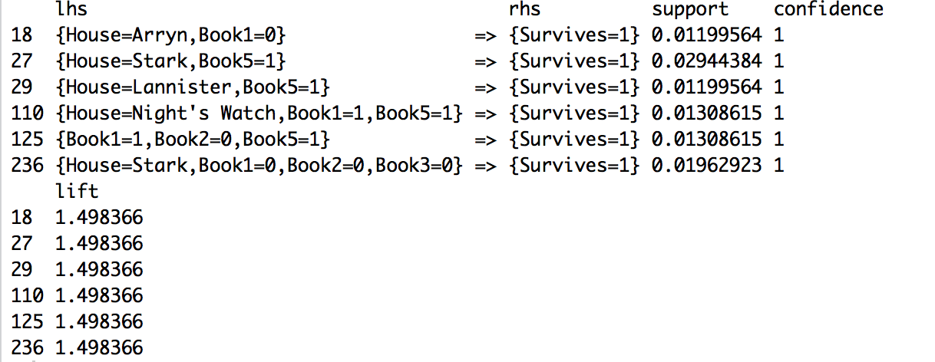

The rules for not survive are as follows:

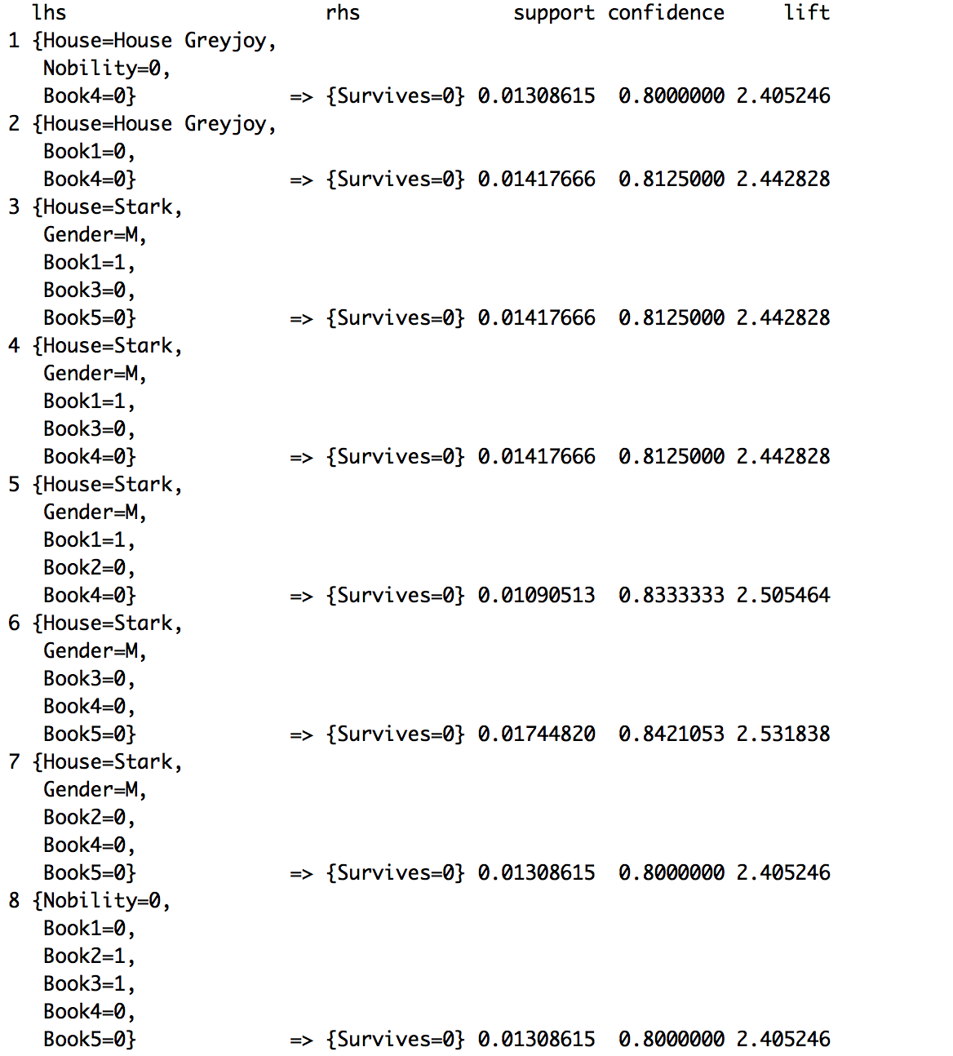

Nobility and gender seem to play a role in whether a character survives or not. When someone is not of nobility or is a male, they survive less. These rules do have less confidence though.

There aren’t rules that say jon snow shouldn’t survive since he is in house of night’s watch and was in the books 1 and 5, he should live.

My favorite character is Daenerys and she should live based on the rule: {House=Targaryen, Book5=1} => {Survives=1}.